

Aria Workflow Test Execution Document

WFLLA-17(XML Statement Processing)

## *Phase 1 :* Custom XML Section – Paystub

*Prepared By: Chitra Singh*

*Execution date : 12/14/2022*

Use case 1: As a user, I want to verify the below Custom fields are populated in enhanced XML File, when the Account has Tokenised credit card as Primary payment method, NTG is English and acct_supp_fields contains “Paper Billing”. 3

Use case 2: As a user, I want to verify the below Custom fields are populated in enhanced XML File, when the Account has Tokenised credit card as the Primary payment method, NTG is English and acct_supp_fields contains “PDF”. 5

Use case 3: As a user, I want to verify the below Custom fields are populated in enhanced XML File, when the Account has no Primary payment method, NTG is English and acct_supp_fields contains “Paper Billing”. 7

Use case 4: As a user, I want to verify the below Custom fields are populated in enhanced XML File, when the Account has tokenised credit card as the payment method, NTG is Spanish and acct_supp_fields contains “Paper Billing”. 10

Use case 5: As a user, I want to verify the below Custom fields are populated in enhanced XML File, when the Account has Tokenised credit card as the Primary payment method, NTG is Spanish and acct_supp_fields contains “PDF”. 12

# Use case 1: As a user, I want to verify the below Custom fields are populated in enhanced XML File, when the Account has Tokenised credit card as Primary payment method, NTG is English and acct_supp_fields contains “Paper Billing”.

XML Section – Paystub

1) ps_auto_flag_hd: True

2) ps_lang_flag_vrb: “English”

3)ps_print_vrb: True

4)ps_cust_typ_vrb:B2C

|  |  |
| --- | --- |
| Action | Details |
| Pre-Conditions | Input XML Statement File with below preconditions  1)Template name is "LLA XML Template English”  2)primary_pay_method_id = "13"  3)acct_supp_fields contains “Paper Billing” |
| WF Server | us-df02 |
| Instance | LLA_DF01 |
| Test Data |  |
| Test Steps |  |
| 1 | 1. Create an account using “create_acct_complete_m” API call in LLADev with below details   1)payment_method : Tokenized Credit Card  2)primary_pay_method_id : "13"  3)NTG :" US LLA XML Template”  4)acct_supp_fields : Paper Billing  Aria core will upload the XML Statement to LLA SFTP |
| 2 | Login to the below work-flow instance,  <https://us-df02.workflow.ariasystems.net/bpa/LLA_DF01/>   1. Navigate to XML Statement Dashboard and run Process File – Main flow   Enhanced XML Statement file will be generated |
|  | Expected Result: <ps_lang_flag_vrb> English</ps_lang_flag_vrb  <ps_auto_flag_hd>True</ps_auto_flag_hd>  <ps_cust_typ_vrb>B2C</ps_cust_typ_vrb>  <ps_print_vrb>True</ps_print_vrb> |
|  | Actual Result: <ps_lang_flag_vrb> English</ps_lang_flag_vrb  <ps_auto_flag_hd>True</ps_auto_flag_hd>  <ps_cust_typ_vrb>B2C</ps_cust_typ_vrb>  <ps_print_vrb>True</ps_print_vrb> |
| Comments | ***PASS*** |
| Account_No | 33234706 |
| Enhanced XML Output file |  |

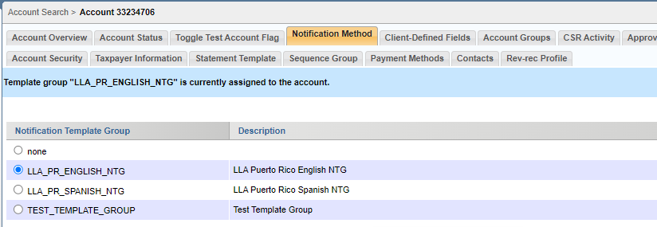

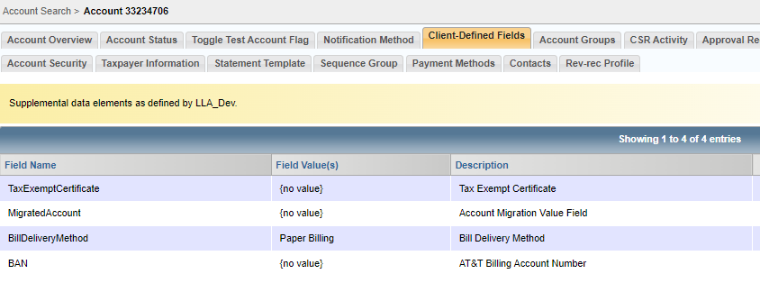

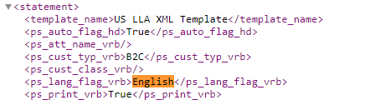

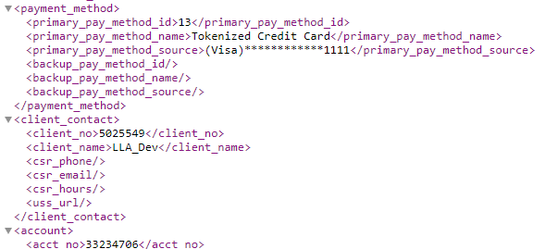

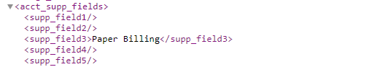

# Use case 2: As a user, I want to verify the below Custom fields are populated in enhanced XML File, when the Account has Tokenised credit card as the Primary payment method, NTG is English and acct_supp_fields contains “PDF”.

XML Section – Paystub

1) ps_auto_flag_hd: True

2) ps_lang_flag_vrb: “English”

3)ps_print_vrb: False

4)ps_cust_typ_vrb:B2C

|  |  |
| --- | --- |
| Action | Details |
| Pre-Conditions | Input XML Statement File with below preconditions  1)Template name is "LLA XML Template English”  2)primary_pay_method_id = "13"  3)acct_supp_fields contains “PDF” |
| WF Server | us-df02 |
| Instance | LLA_DF01 |
| Test Data |  |
| Test Steps |  |
| 1 | 1. Create an account using “create_acct_complete_m” API call in LLADev with below details   1)payment_method : Tokenized Credit Card  2)primary_pay_method_id : "13"  3)NTG :" US LLA XML Template”  4)acct_supp_fields : PDF  Aria core will upload the XML Statement to LLA SFTP |
| 2 | Login to the below work-flow instance,  <https://us-df02.workflow.ariasystems.net/bpa/LLA_DF01/>   1. Navigate to XML Statement Dashboard and run Process File – Main flow   Enhanced XML Statement file will be generated |
|  | Expected Result: <ps_lang_flag_vrb> English</ps_lang_flag_vrb  <ps_auto_flag_hd>True</ps_auto_flag_hd>  <ps_cust_typ_vrb>B2C</ps_cust_typ_vrb>  <ps_print_vrb>False</ps_print_vrb> |
|  | Actual Result: <ps_lang_flag_vrb> English</ps_lang_flag_vrb  <ps_auto_flag_hd>True</ps_auto_flag_hd>  <ps_cust_typ_vrb>B2C</ps_cust_typ_vrb>  <ps_print_vrb>False</ps_print_vrb> |
| Comments | ***PASS*** |
| Account_No | ***33234998*** |
| Enhanced XML Output file |  |

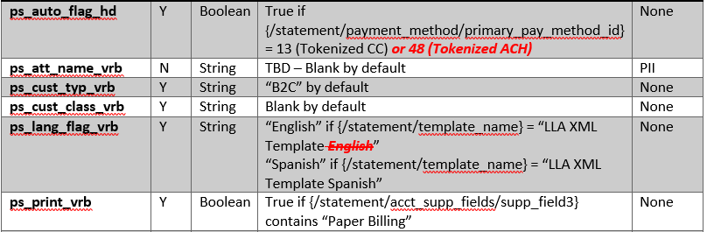

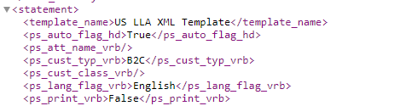

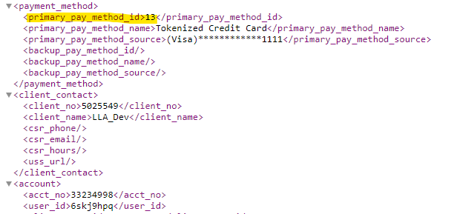

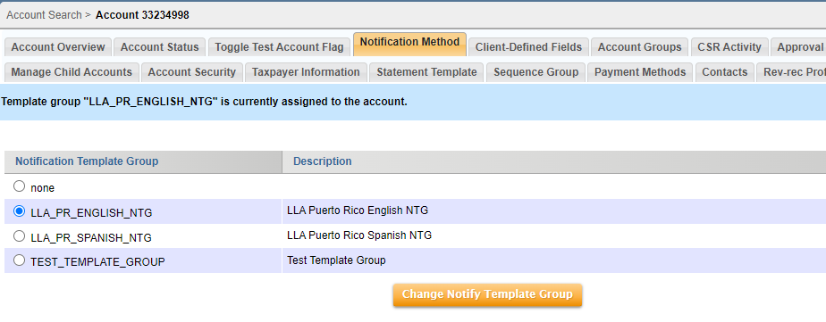

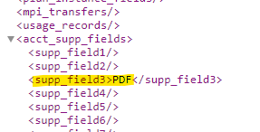

# Use case 3: As a user, I want to verify the below Custom fields are populated in enhanced XML File, when the Account has no Primary payment method, NTG is English and acct_supp_fields contains “Paper Billing”.

XML Section – Paystub

1) ps_auto_flag_hd: False

2) ps_lang_flag_vrb: “English”

3)ps_print_vrb: True

4)ps_cust_typ_vrb:B2C

|  |  |
| --- | --- |
| Action | Details |
| Pre-Conditions | Input XML Statement File with below preconditions  1)Template name is "LLA XML Template English”  2)primary_pay_method_id = null  3)acct_supp_fields contains “Paper Billing” |
| WF Server | us-df02 |
| Instance | LLA_DF01 |
| Test Data |  |
| Test Steps |  |
| 1 | 1. Create an account using “create_acct_complete_m” API call in LLADev with below details   1)payment_method : Tokenized Credit Card  2)primary_pay_method_id : null  3)NTG :" US LLA XML Template”  4)acct_supp_fields : Paper Billing  Aria core will upload the XML Statement to LLA SFTP |
| 2 | Login to the below work-flow instance,  <https://us-df02.workflow.ariasystems.net/bpa/LLA_DF01/>   1. Navigate to XML Statement Dashboard and run Process File – Main flow   Enhanced XML Statement file will be generated |
|  | Expected Result: <ps_lang_flag_vrb> English</ps_lang_flag_vrb  <ps_auto_flag_hd>False</ps_auto_flag_hd>  <ps_cust_typ_vrb>B2C</ps_cust_typ_vrb>  <ps_print_vrb>True</ps_print_vrb> |
|  | Actual Result: <ps_lang_flag_vrb> English</ps_lang_flag_vrb  <ps_auto_flag_hd>False</ps_auto_flag_hd>  <ps_cust_typ_vrb>B2C</ps_cust_typ_vrb>  <ps_print_vrb>True</ps_print_vrb> |
| Comments | ***PASS*** |
| Account_No | ***33235013*** |
| Enhanced XML Output file |  |

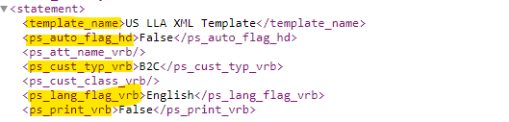

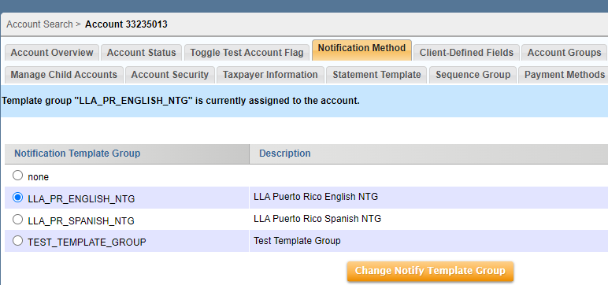

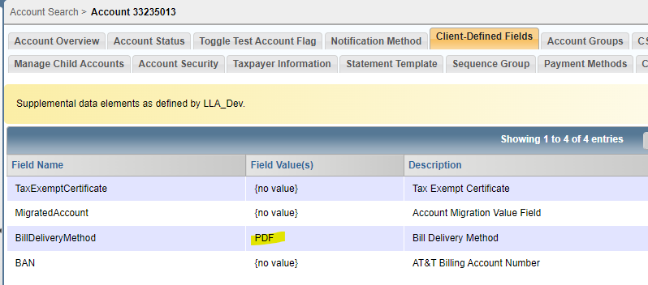

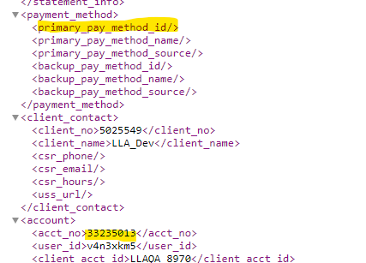

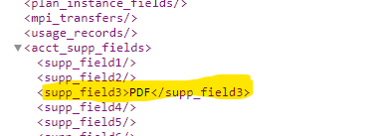

# Use case 4: As a user, I want to verify the below Custom fields are populated in enhanced XML File, when the Account has tokenised credit card as the payment method, NTG is Spanish and acct_supp_fields contains “Paper Billing”.

XML Section – Paystub

1) ps_auto_flag_hd: True

2) ps_lang_flag_vrb: “Spanish”

3)ps_print_vrb: True

4)ps_cust_typ_vrb: B2C

|  |  |
| --- | --- |
| Action | Details |
| Pre-Conditions | Input XML Statement File with below preconditions  1)Template name is "LLA XML Template Spanish”  2)primary_pay_method_id = "13"  3)acct_supp_fields contains “Paper Billing” |
| WF Server | us-df02 |
| Instance | LLA_DF01 |
| Test Data |  |
| Test Steps |  |
| 1 | 1. Create an account using “create_acct_complete_m” API call in LLADev with below details   1)payment_method : Tokenized Credit Card  2)primary_pay_method_id : "13"  3)NTG :"LLA XML Template Spanish”  4)acct_supp_fields : Paper Billing  Aria core will upload the XML Statement to LLA SFTP |
| 2 | Login to the below work-flow instance,  <https://us-df02.workflow.ariasystems.net/bpa/LLA_DF01/>   1. Navigate to XML Statement Dashboard and run Process File – Main flow   Enhanced XML Statement file will be generated |
|  | Expected Result: <ps_lang_flag_vrb>Spanish</ps_lang_flag_vrb  <ps_auto_flag_hd>True</ps_auto_flag_hd>  <ps_cust_typ_vrb>B2C</ps_cust_typ_vrb>  <ps_print_vrb>True</ps_print_vrb> |
|  | Actual Result: <ps_lang_flag_vrb> English</ps_lang_flag_vrb  <ps_auto_flag_hd>True</ps_auto_flag_hd>  <ps_cust_typ_vrb>B2C</ps_cust_typ_vrb>  <ps_print_vrb>True</ps_print_vrb> |
| Comments | ***PASS*** |
| Account _no | ***33234709*** |
| Enhanced XML Outputfile |  |

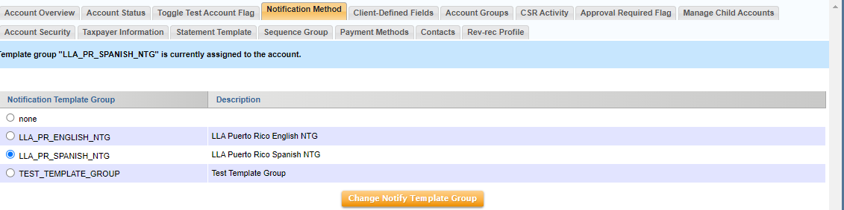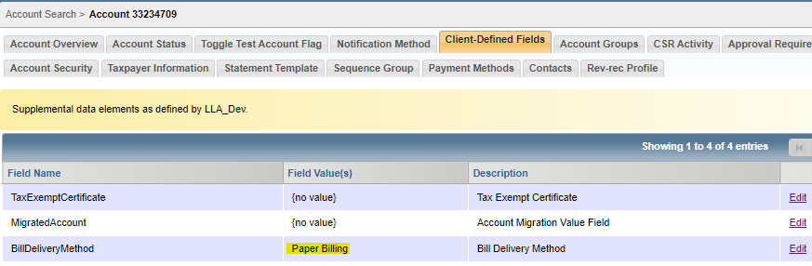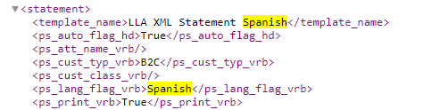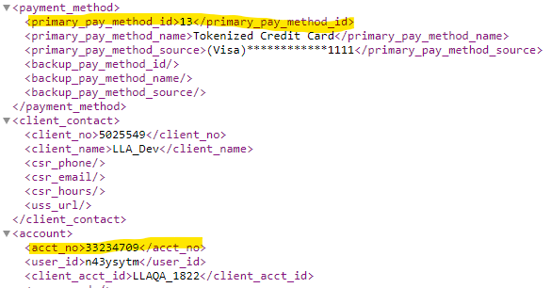

# Use case 5: As a user, I want to verify the below Custom fields are populated in enhanced XML File, when the Account has Tokenised credit card as the Primary payment method, NTG is Spanish and acct_supp_fields contains “PDF”.

XML Section – Paystub

1) ps_auto_flag_hd: True

2) ps_lang_flag_vrb: “Spanish”

3)ps_print_vrb: False

4)ps_cust_typ_vrb: B2C

|  |  |
| --- | --- |
| Action | Details |
| Pre-Conditions | Input XML Statement File with below preconditions  1)Template name is "LLA XML Template Spanish”  2)primary_pay_method_id = "13"  3)acct_supp_fields contains “PDF” |
| WF Server | us-df02 |
| Instance | LLA_DF01 |
| Test Data |  |
| Test Steps |  |
| 1 | 1. Create an account using “create_acct_complete_m” API call in LLADev with below details   1)payment_method : Tokenized Credit Card  2)primary_pay_method_id : "13"  3)NTG :"LLA XML Template Spanish”  4)acct_supp_fields : PDF  Aria core will upload the XML Statement to LLA SFTP |
| 2 | Login to the below work-flow instance,  <https://us-df02.workflow.ariasystems.net/bpa/LLA_DF01/>   1. Navigate to XML Statement Dashboard and run Process File – Main flow   Enhanced XML Statement file will be generated |
|  | Expected Result: <ps_lang_flag_vrb>Spanish</ps_lang_flag_vrb  <ps_auto_flag_hd>True</ps_auto_flag_hd>  <ps_cust_typ_vrb>B2C</ps_cust_typ_vrb>  <ps_print_vrb>False</ps_print_vrb> |
|  | Actual Result: <ps_lang_flag_vrb> Spanish</ps_lang_flag_vrb  <ps_auto_flag_hd>True</ps_auto_flag_hd>  <ps_cust_typ_vrb>B2C</ps_cust_typ_vrb>  <ps_print_vrb>False</ps_print_vrb> |
| Comments | ***PASS*** |
| Account _no | ***33232259*** |
| Enhanced XML Outputfile |  |

